An Inspector Calls Revision

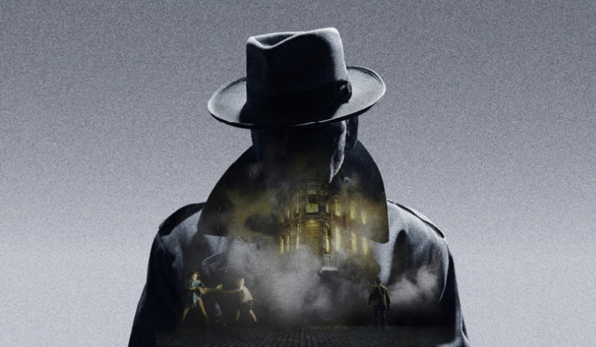

How to use:

1. Fill in the boxes about the character or theme.
2. Annotate the 5 key quotes exploring: what is shows/devices used/links to context.

Name:­­­____________

Set:______

Teacher:__________

What are 5 key events the character is in?



Mr Birling: What type of a character is he? Does he change throughout the play? What role does he play?

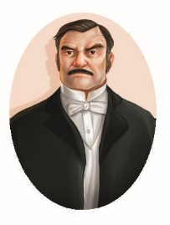

Writer’s Intention – How has Priestley used this character?

What are 5 key events the character is in?

Sheila: What type of a character is she? Does she change throughout the play? What role does she play?

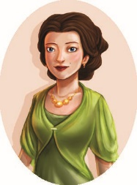

Writer’s Intention – How has Priestley used this character?

What are 5 key events the character is in?

Gerald: What type of a character is he? Does he change throughout the play? What role does he play?



Writer’s Intention – How has Priestley used this character?

What are 5 key events the character is in?

Mrs Birling: What type of a character is she? Does she change throughout the play? What role does she play?

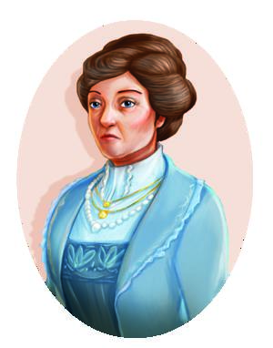

Writer’s Intention – How has Priestley used this character?

What are 5 key events present this character?

Eric: What type of a character is he? Do he change throughout the play? What role does he play?

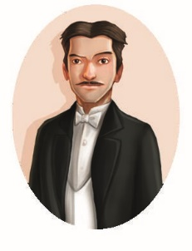

Writer’s Intention – How has Priestley used these characters?

What are 5 key events present this character?



The Inspector: What type of a character is he? Do he change throughout the play? What role does he play?

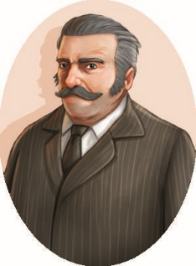

Writer’s Intention – Why has Priestley included this character?

What are 5 key events present this character?



Eva: What type of a character is she? Does she change throughout the play? What role does she play?

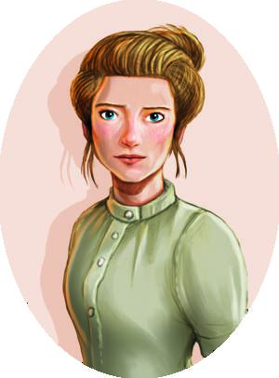

Writer’s Intention – Why has Priestley included this character?

What are 5 key events present this theme?



Responsibility: What is it? Which characters are affected by this? What is the effect of this?

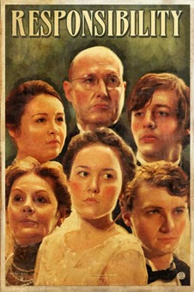

Writer’s Intention – Why has Priestley included this theme?

What are 5 key events present this theme?



Class: What is it? Which characters are affected by this? What is the effect of this?

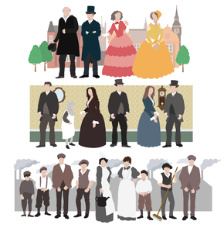

Writer’s Intention – Why has Priestley included this theme?

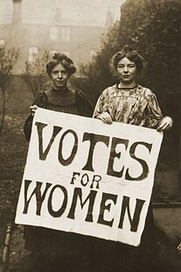

Writer’s Intention – Why has Priestley included this theme?

Gender: What is it? Which characters are affected by this? What is the effect of this?

Gender: What is it? Which characters are affected by this? What is the effect of this?

What are 5 key events present this theme?



What are 5 key events present this theme?



Age: What is it? Which characters are affected by this? What is the effect of this?

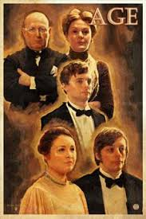

Writer’s Intention – Why has Priestley included this theme?